

# Books Library

# Group Members:

## Sushmita Nandalan – 300923159

## Chanpreet Mudhar – 300932732

Table of Contents

Books Library 1

Group Members: 1

Sushmita Nandalan – 300923159 1

Chanpreet Mudhar – 300932732 1

Detailed description 3

Version History 3

GITHUB SCREENCAPTURE 3

Typography and Color 4

Wireframes 5

Capture Section 5

# Detailed description

A website that shows a books library which has a wide variety of books from various authors and genres. In this website, we have Home page, List page, Contacts page, and AddBooks page. The main page i.e. the home page will show a brief description about our library and will include a button that will take the user to the list page, hence displaying the collection of books in a list with all the details including Book title, ISBN, Author, Genre, Format, and Rating. Also, there is a separate link to the list page in the navigation bar which also opens up the same page that displays a list of all the books. Also, we have a contact page that shows all the contact information and address for our library. Furthermore, we have an AddBooks page, rather an update page that allows user to enter information about their favorite book. The user would then fill all the details and click on the update button, which will update all the information about the book.

# Version History

(at least 4-5)

V0.1 Site structure and main page

V0.2 Connected to the database and displayed list of books in the list page

V1.0 Full featured release site.

## GITHUB SCREENCAPTURE

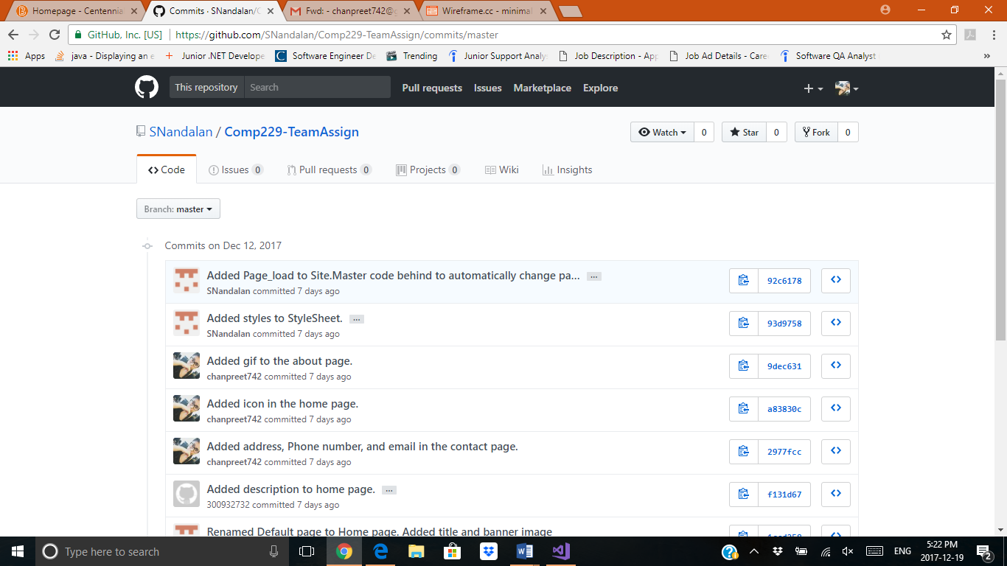

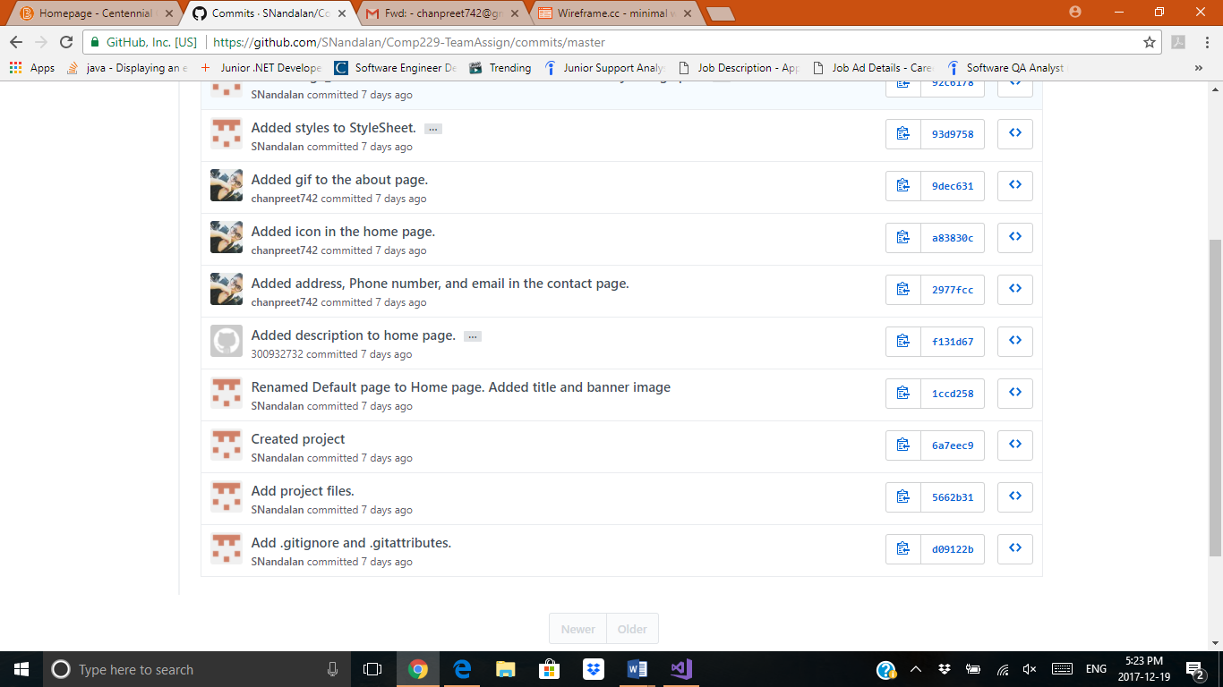

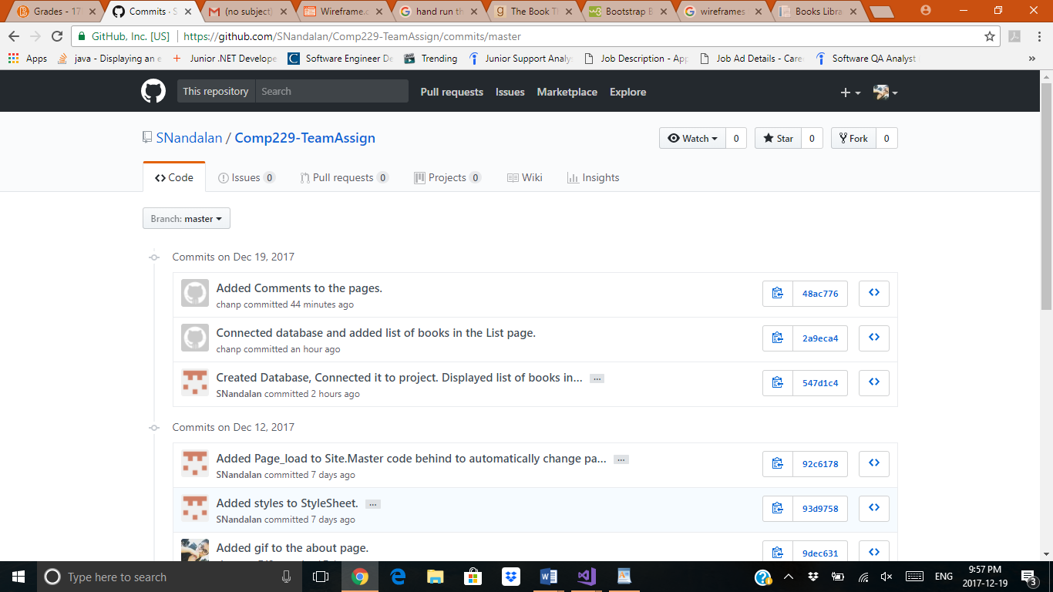

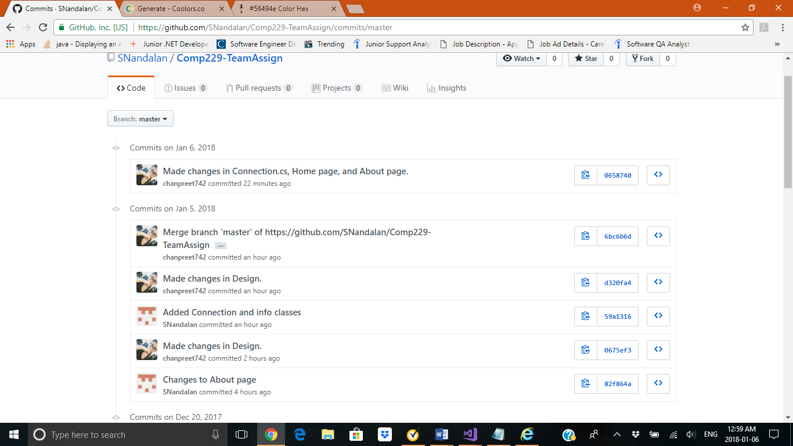

# Typography and Color

All fonts are client defaults

Lucida Sans

|  |  |  |
| --- | --- | --- |
| #0000 | |  | | --- | |  | |
| #56494E | |  | | --- | |  | |
| #D6D7DF | |  | | --- | |  | |

# Wireframes

1. Wireframe for home page:

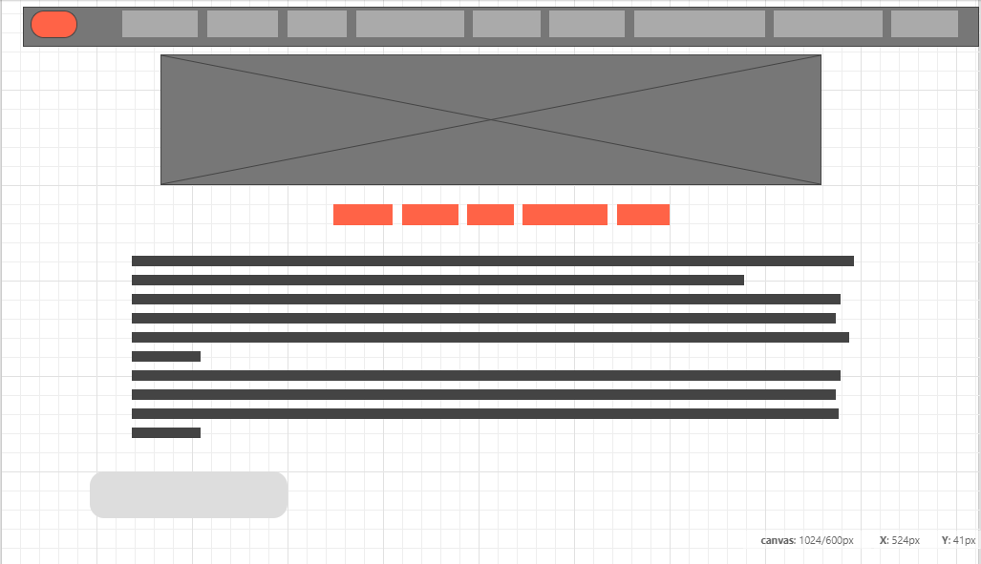

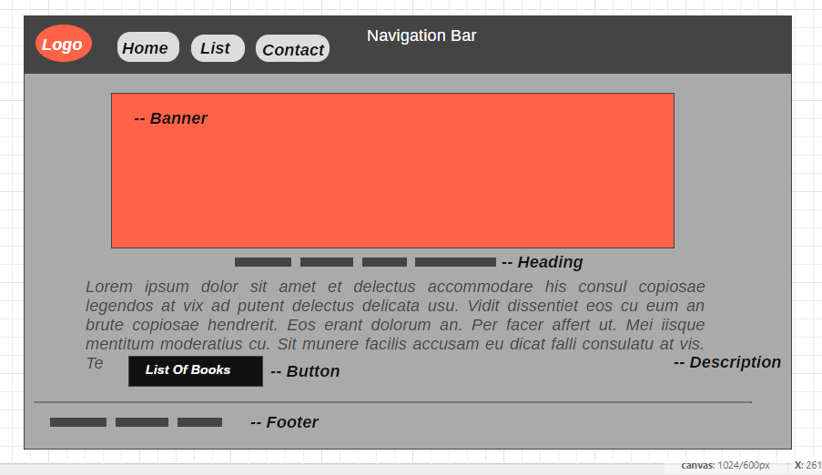

1. Wireframe for List Page:

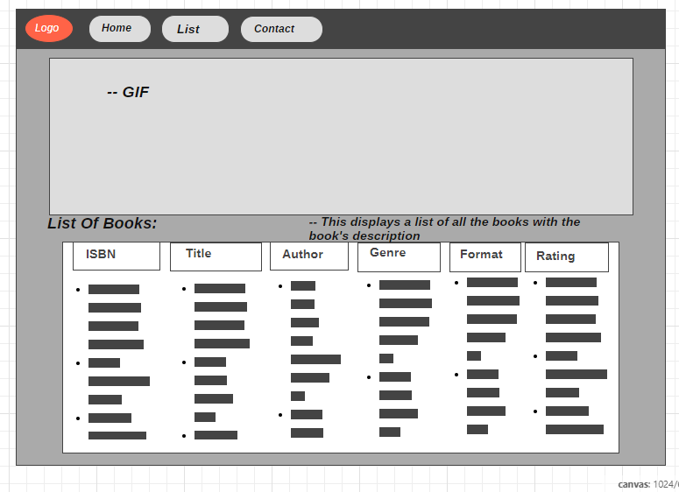

1. Wireframe for Contact Page:

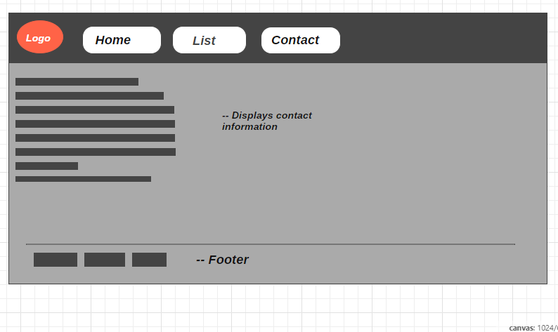

# Capture Section

